Create database
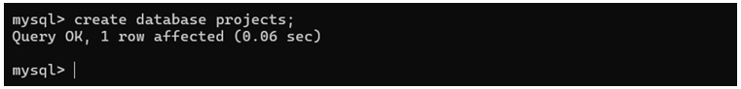

Create table users
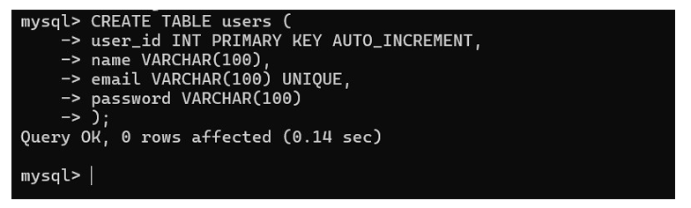

Insert data into user
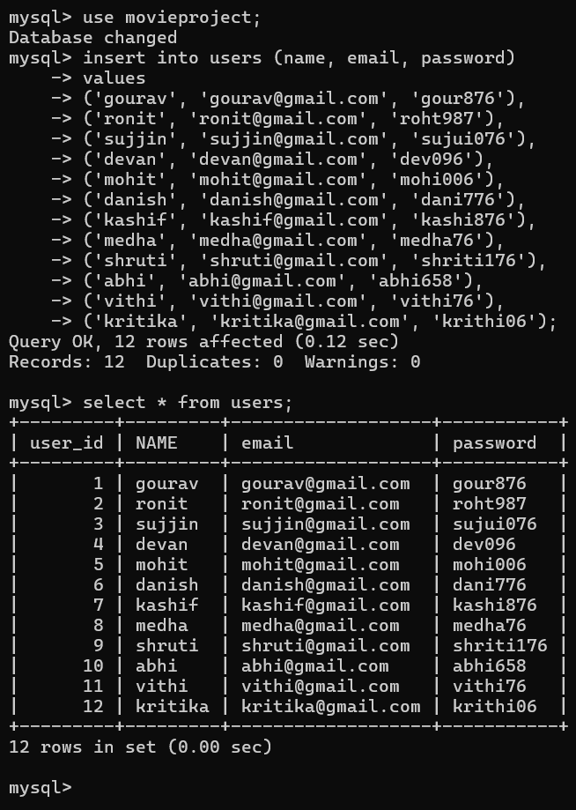

CREATE TABLE MOVIES
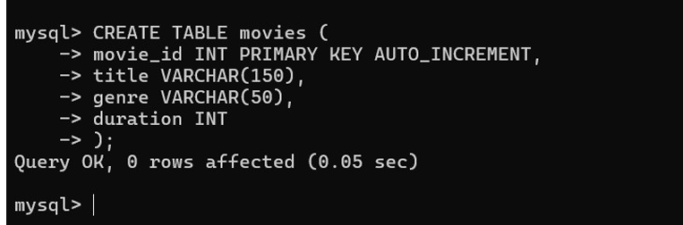

INSERT DATA INTO MOVIES
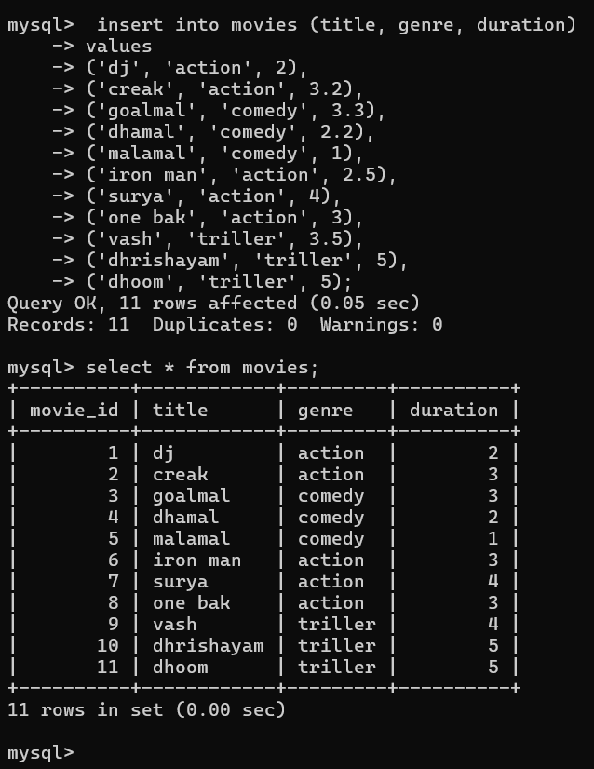

CREATE TABLE SHOWS
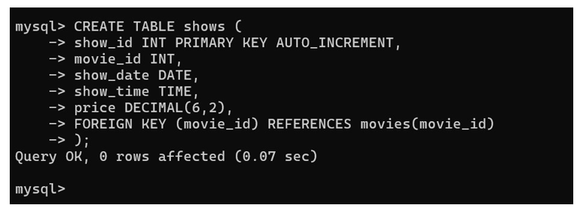

INSERT DATA INTO SHOWS

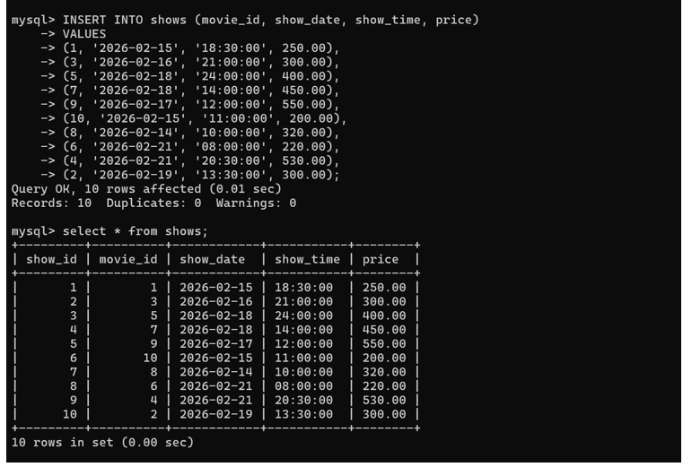

CREATE TABLE SEATS
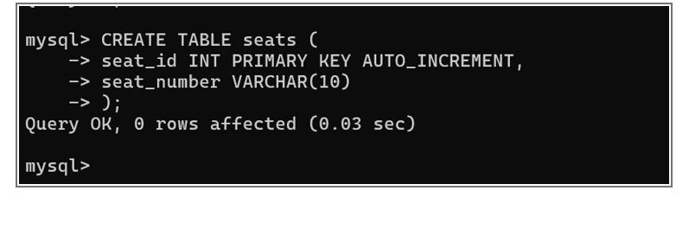

INSERT DATA INTO SEATS

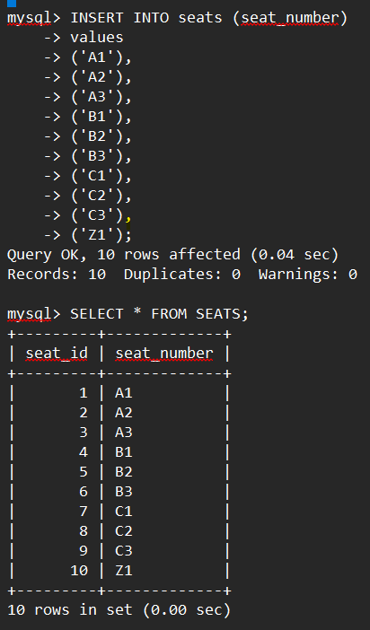

CREATE TABLE BOOKINGS
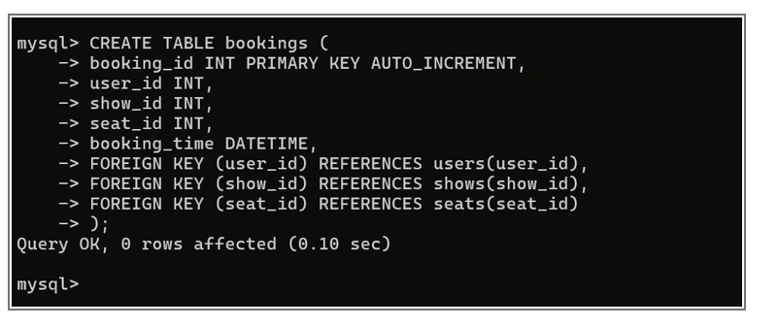

INSERT DATA INTO BOOKINGS
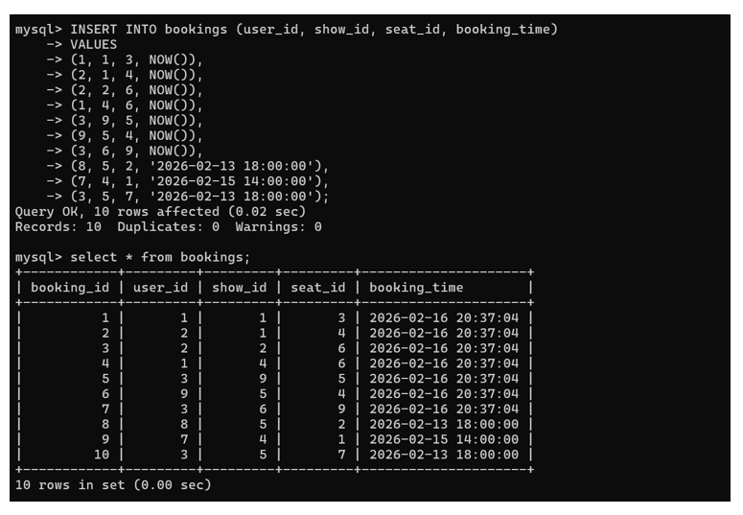

SHOW ALL THE

TABLES

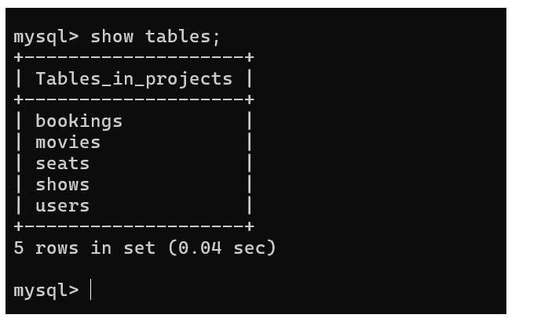

Write a query to display all users stored in the system.
- 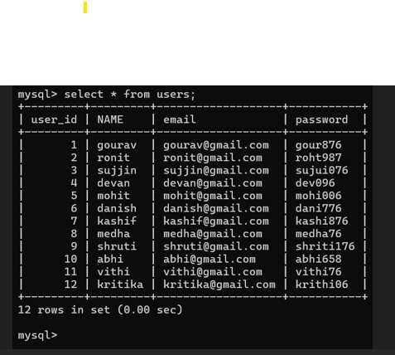

2.Write a query to list all movies in the movie table.
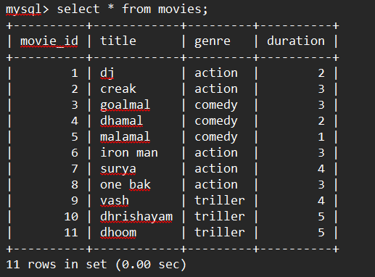

3.Write a query to display all
available shows
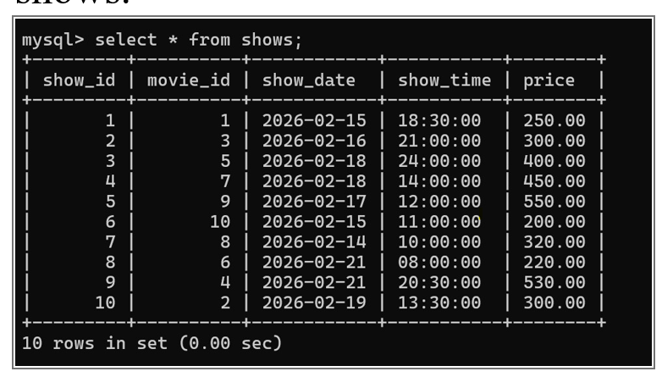
4.Write a query to fetch details of amovie using its movie_id.

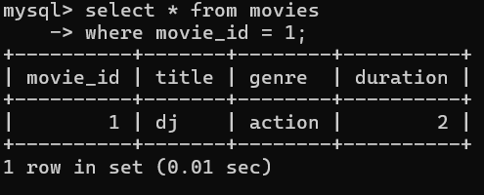
5.Write a query to list all shows of a particular movie
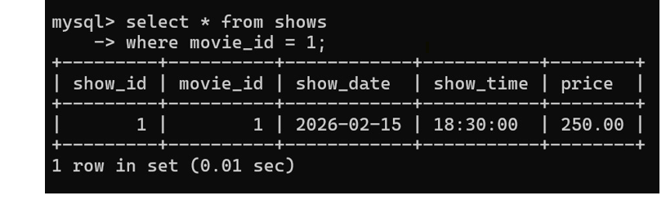

6.Write a query to list all seat numbers from the seats table.

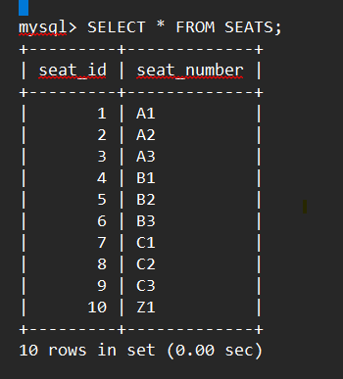

7.Write a query to find available seats for a specific show.

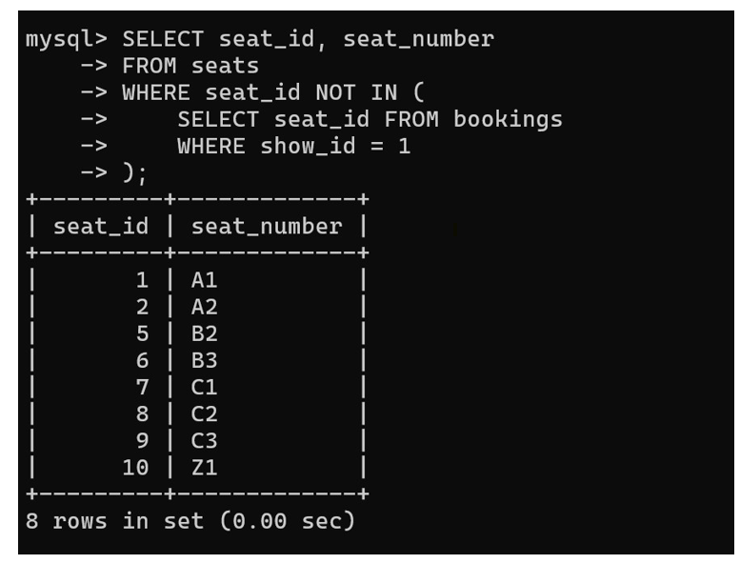

8.Write a query to display all booked seats for a specific show.

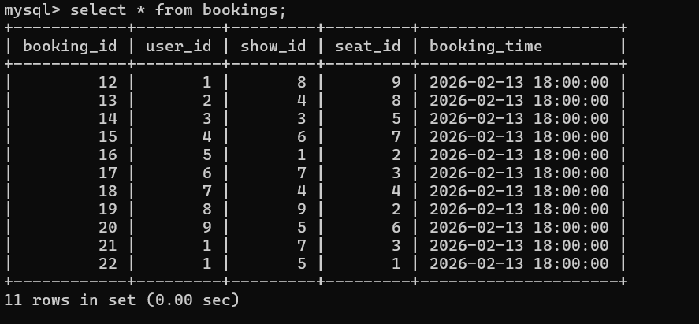
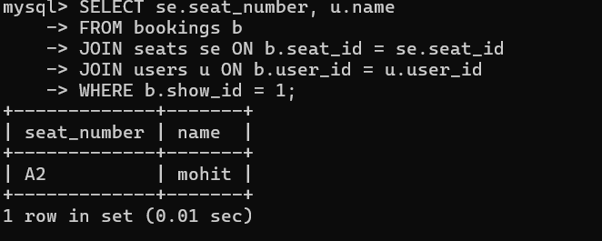

9.Write a query to insert a new user into the users table.
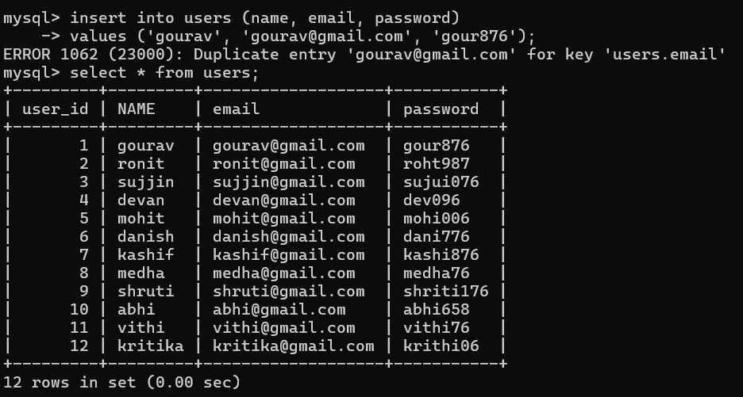

10. Write a query to insert a new movie into the movies table.
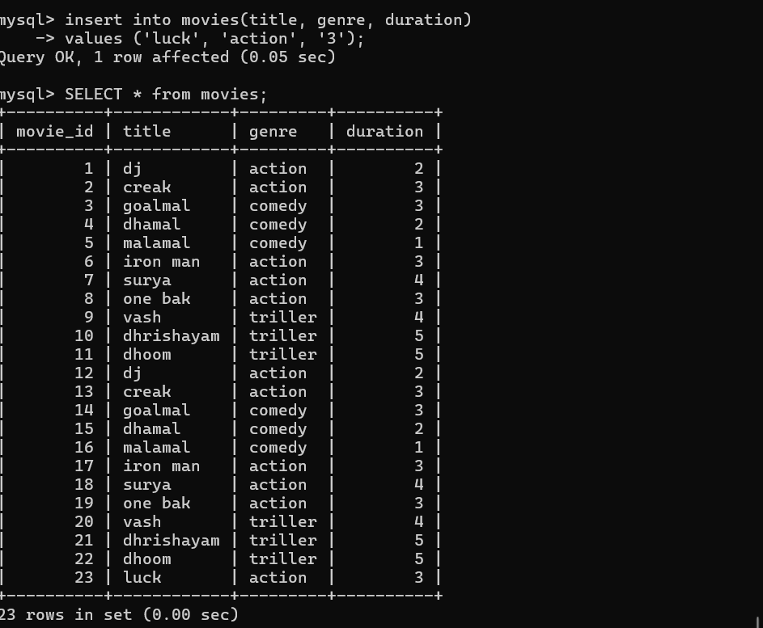

11. Write a query to insert a new show into the shows table
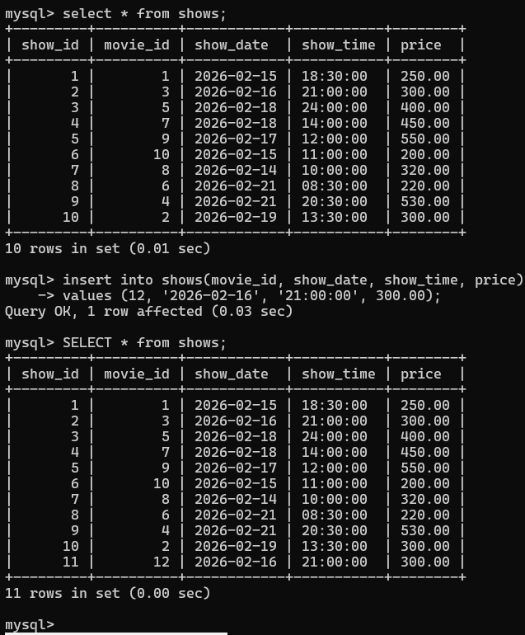

12.Write a query to add a new seat to the seats table

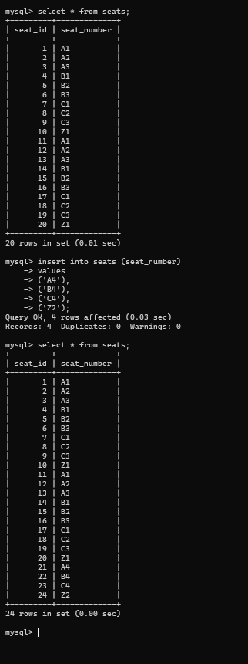

13.Write a query to book a ticket for a user.
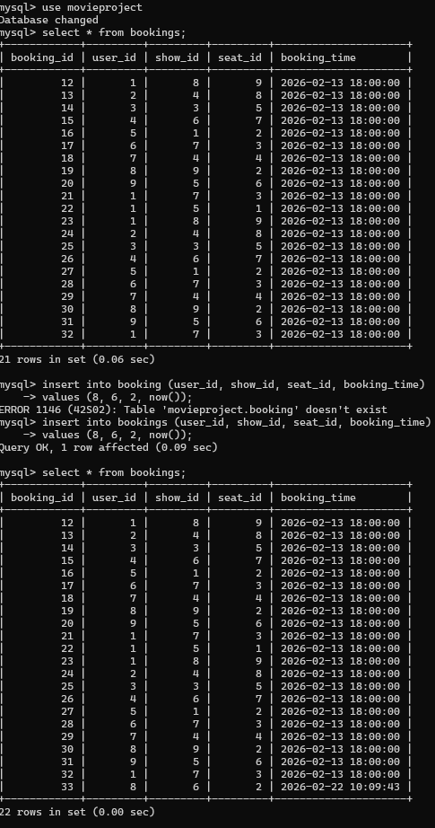

14.Write a query to display all bookings
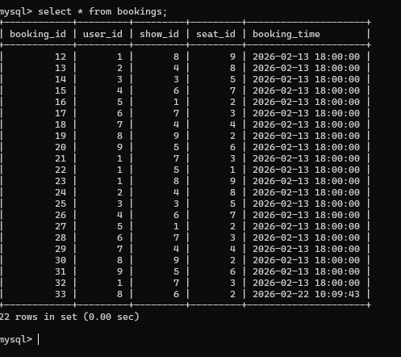

15.Write a query to display booking history for a specific user.
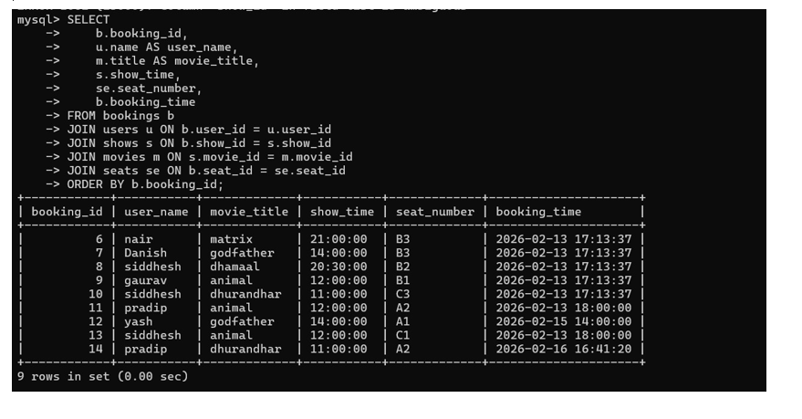

16.Write a query to count totalbookings for a specific

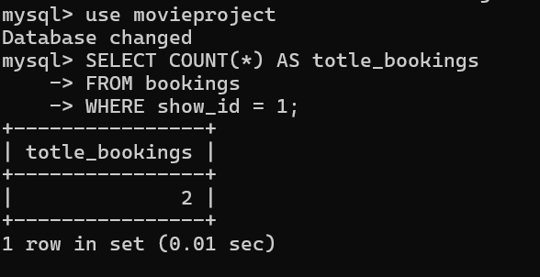

17.Write a query to count total bookings for a specific movie.

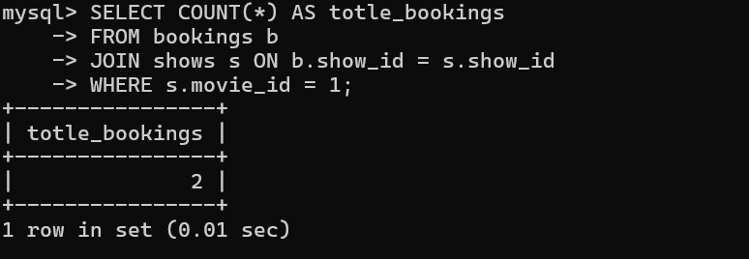

18.Write a query to find all movies of a specific genre.

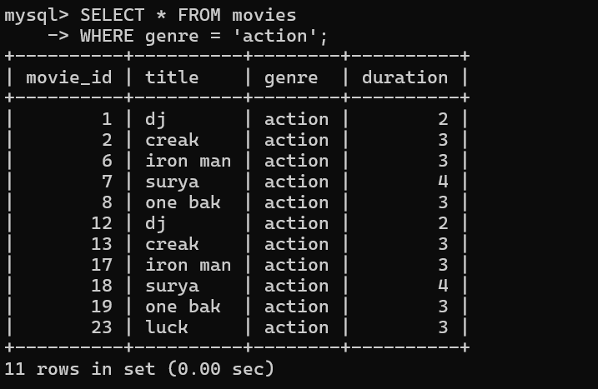

19.Write a query to update the

duration of a movie.
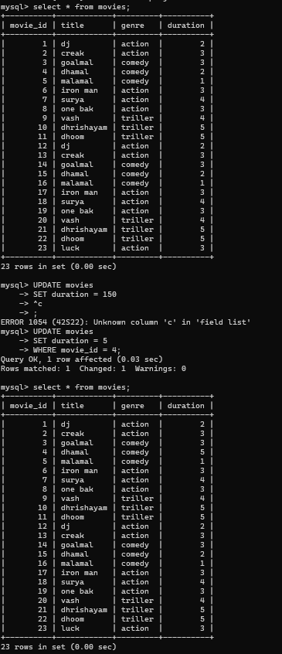

20.Write a query to update the seat number for a given seat_id.
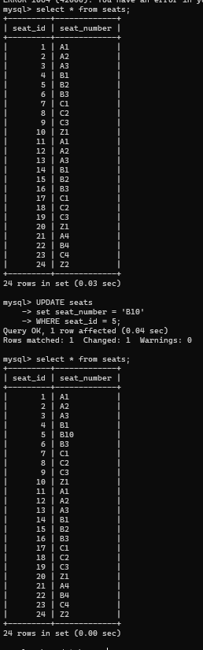

21. Write a query to delete a specificbooking

record.

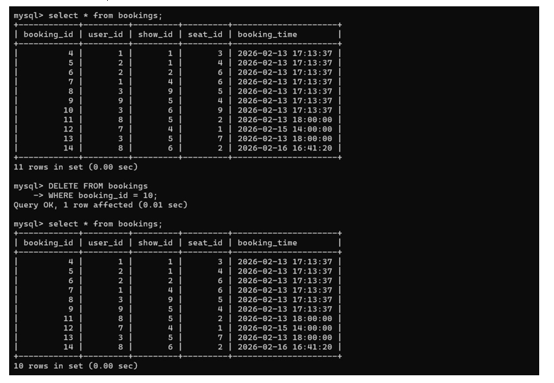

22. Write a query to delete a moviefrom the movies table.

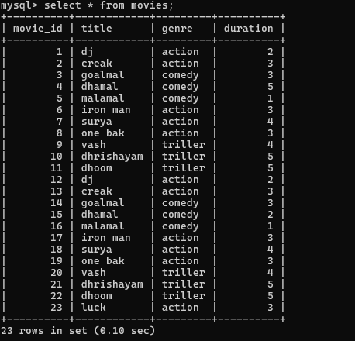

23.Write a query to list movieslonger than 2 hours
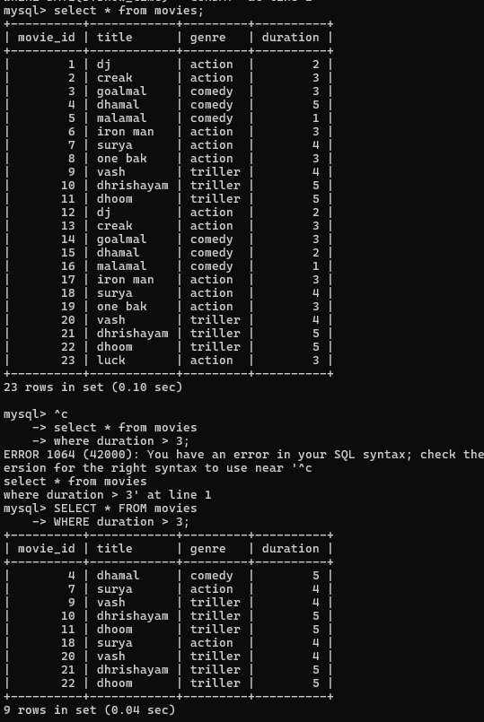

24.Write a query to find showsscheduled for today's date.

25.Write a query to list upcomingshows sorted by date and

time.
